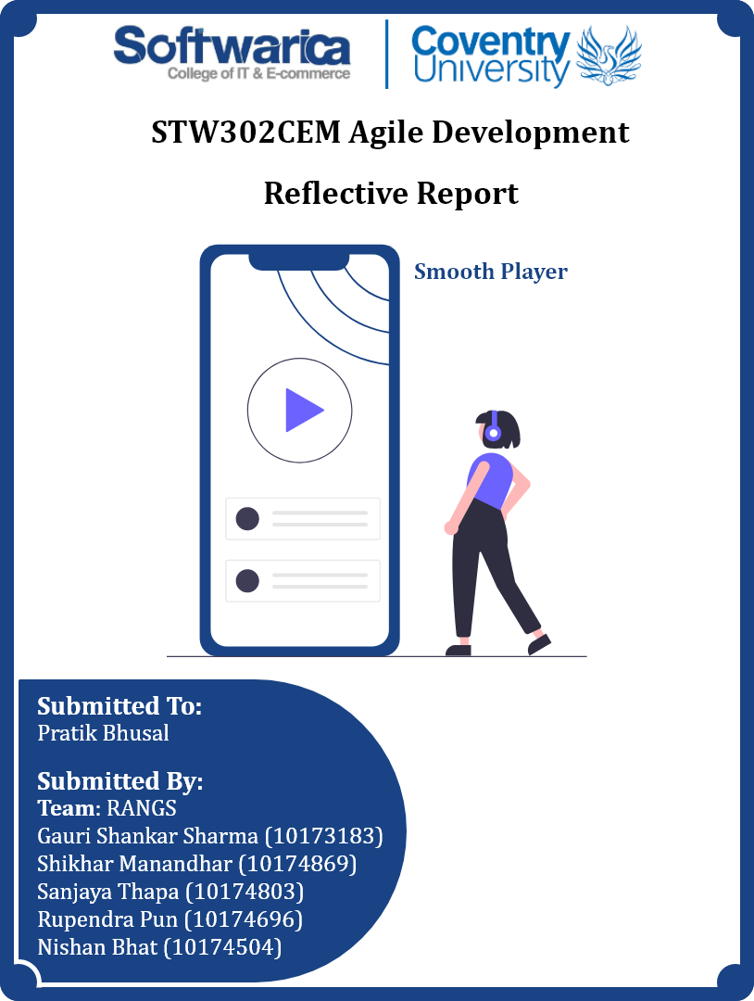

**Table of Contents**

**Introduction** 1

**Team Psychology** 2

**Team** 2

**Team Performance** 2

**Conflict Management** 2

**Leadership** 2

**Team Work** 3

**Communication** 4

**Team communication** 4

**Communication theory** 4

**Issue of communications** 4

**Agile Process** 6

**Our Team** 6

**User Story** 6

**Product Backlog** 7

**Map Board** 8

**Release Plan** 8

**Sprint Planning and Backlog** 9

**Daily Stand-Ups** 10

**Sprint Review** 11

**Retro** 12

**Why Scrum** 12

**Conclusion** 14

**Links** 15

**Trello:** 15

**Google Sheet:** 15

**Adobe XD (Google Drive File Link):** 15

**Figma:** 15

**References** 16

**Table of Figures**

Figure 1: Rang Team members 6

Figure 2: Agile User Stories 6

Figure 3: Trello Product Backlog 7

Figure 4: User Story Map Board 8

Figure 5: Agile User Stories Release Plan 8

Figure 6: Sprint Planning 9

Figure 7: Microsoft Team Daily Stand-Up Meeting 10

Figure 8: Sprint Review Meeting 11

Figure 9: Retrospective Meeting Detail 12

# **Introduction**

Smooth Player is an online music application that is developed for mobile platforms using Flutter and NodeJS. Agile Scrum methodology has been used for software development methodology (SDM) in this project. There are lots of music apps for mobile in the market like Spotify but they provide only limited features. To get all the features, users need to buy the premium version. Therefore, a music app that provides all the features including the premium features that everyone desires to have in a music app without spending any money is the main goal of this project. Users can upload songs and albums, follow artists (verified users), like albums and songs, and listen to their songs too. There is no advertisement and limitation on playing songs like shuffle play only or limited skip which brings better flexibility to the users. Five members who are very well known to each other were assigned to this project. Microsoft team has been used to arrange the meetings between the team members. Similarly, a google excel sheet has been used to record the user stories, task division, and the team works. The user story map board has been made on Trello. Developers have worked on git branching and merging according to the user stories to have better control and reduce conflicts in the application development part. A desktop app or a web app also could be the options for developing the project rather than targeting mobile users but there would be limited users of the system and the system also could not provide the flexibility that mobile apps can provide like portability.

# **Team Psychology**

## **Team**

Whenever individuals cooperate to achieve a shared objective, teamwork occurs. Understanding how each member of the team works both individually and collectively is the first step in forming the team. Each team member must be sufficiently aware of their personality to be able to explain how they behave while interacting with others. Individuals rarely learn, work, or appreciate things in the same ways (Waters, 2022). Understanding the personal expectations of each team member as well as the expectations of the other team members is the foundation of collaboration. This is followed by the creation of a supportive structure. selecting which personal expectations can be met while working together effectively while utilizing the strengths, developing the shortcomings as necessary, and doing so. Team RANGS was founded in this way.

## **Team Performance**

The performance of an Agile team may be evaluated using only four measures. namely, predictability, productivity, quality, and stability. Using predictability as a metric, all of the items in the product backlog were finished on schedule. After the Sprint, the team has finished all of the work that they agreed to undertake at the beginning of the Sprint. When it comes to quality, the consumer appears to be more pleased with the product as the defect rate is lower, which translates to a happier customer. A shorter cycle time results in more work being completed within the allotted timeframe when productivity is taken into account. The last one is Stability; the team is probably close to or has already reached its breaking point because all other metrics are excellent. Since team members appear to be happy, there are no obvious signs of underlying issues or other potential concerns.

## **Conflict Management**

The main challenge of teamwork is time management. While some members do have some free time, others do not during the same time. It must be managed because sprint meetings and daily standups should be on time. To resolve this dispute, the team should first get together, solicit input from the larger group, create a new strategy, then implement that plan. The following step is task division, which is the busiest element of the group after time management. It is more challenging for the members who received the frontend portion, where they must create a UI that is identical to the prototype provided because not all tasks are equally distributed at the initial sessions. Giving one person both the frontend and backend of work helps the team avoid disputes and improves team performance, which helps to resolve this member conflict.

## **Leadership**

The team members' communication with the agile leader or scrum master was open and honest. Eliminating barriers to team members' everyday accomplishment of their priorities is the team leader's first admirable accomplishment. Scrum masters worked hard to remove obstacles. The scrum master was always monitoring and listening. The scrum master enlisted feedback from the product owner while team members were handling a problem to create more efficient processes. Scrum master was always there to assist team members in resolving all issues inside the sprint if there is a coding error or someone was unable to handle the issue. When a team member forgets to show up for a meeting, the team leader served as a reminder to the other team members. Additionally, the scrum master always let the teacher know about the member who is unable to attend the meeting, which is a commendable effort. Also, the leader reminded all of the remaining work if a member forgets to finish in time.

## **Team Work**

Listing out all the tasks to develop the app is the first work. After the task listing process was finished, the next task was to divide and distribute the task in different sprints equally so there won’t be any pressure in any sprint. All the tasks were divided equally among every member so that the task finishes within the sprint. All the members were given both the backend and frontend parts of tasks which makes the team work faster. The major accomplishment of teamwork was helping each other. There were some cases in which some team member could not complete their assigned task. For this, another team member also helped to complete the task. But there was not any case of moving a sprint task into another sprint because all the tasks of each sprint were completed in time.

# **Communication**

## **Team communication**

Communication among team members develops cooperation, explains every stage of the project lifecycle, and enhances general awareness of requirements (Teamrg, 2022). Face-to-face communication meetings were organized to address any misunderstandings that a video conference between team members was unable to address. Everyone was present at this meeting in person. Following that, all team member discusses their concerns with the project. A remedy is put forth after team members have had an opportunity to consider the issue. To ensure that everyone could participate, in-person sessions were organized on college premises throughout the completion of the project. In a face-to-face encounter, coding-related difficulties were discussed. This meeting benefitted us by providing rapid replies, solid working connections, enhanced productivity, minimized misunderstandings and boosted team participation (Bhasin, 2021). When a team member was unable to attend a meeting, both physically and virtually, phone-to-phone conservation was held. This meeting was exceptional because all team members were dedicated to completing the project. This meeting has a relatively short time (1-2 min).

## **Communication theory**

According to the study, there are three communication theories: classical communication theory, human relations communication theory, and open system communication theory. The classical theory of communication is a top-down technique in which the principal (team leader) issues orders to the instructors (team members), and the instructors give feedback to the principal on the effectiveness of their task. According to the Human Relations Theory of Communication, both the sender and receiver must work hard to understand the inaccuracies and loopholes that frequently arise between perceiving and receiving messages. Furthermore, the transfer of messages and meaning between an institution and its surroundings, as well as between its networks of interdependent subsystems, is described by the open system theory of communication. As a communication theory, classical communication theory has been adopted. As a team leader, the scrum master assists the rest of the team to finish the job. The team's communication is also formed in a structured, hierarchical, and scheduled way. This strategy is appropriate for scrum since a sprint review meeting was scheduled at the end of each daily scrum meeting to summarize our progress and submit the feature to the scrum master. If a team member fails to finish a job, the scrum master is informed. The scrum master then proposes a method to accomplish the task within the timeframe. As a result, job efficiency became maximized, and a small portion of the usable product was delivered to the user (Essays, 2022).

## **Issue of communications**

There were a few issues during team communication. However, those were resolved though they may take some time. E.g., if there was no electricity during the meeting then the meeting would be shifted for a few minutes or an hour till electricity. Each team member is connected to different social media platforms such as Messenger, Viber, etc. But some team members didn’t respond to the message on trying to contact them to share important information. This issue slowed down team productivity. Another issue was the internet. Due to the poor internet connectivity, few team members were unable to attend the meeting so he had to use mobile data to join the meeting. Most of the time physical meetings were set up so that everyone can stay together and do their work. Occasionally during important conservation, a few team members had to leave the meeting early. This caused conflict in the team, which later on was resolved. Hence even if there were issue any issues during the communication the team members would actively act and solve the issue.

# **Agile Process**

## **Our Team**

Figure 1: Rang Team members

Our team member consists of five members. Gauri Shankar Sharma is our Scrum Master whereas Nishan Bhat, Sanjaya Thapa, Shikhar Manandhar, and Rupendra Pun are the developers. Our Scrum Master also acts as our Product Owner. During the time of the sprint, all the tasks were divided in the sprint planning meeting and the tasks were divided among the members. The development team all completed their tasks in time. All the tasks were completed with the help of team coordination and with the help of each other. All the problems and misunderstandings that arose during the sprints among the members were solved with the help of each other and understanding among the members. All the members act understandingly and behave well with each other which helps our team to develop and complete the task in the given time without any problems. With the help of each member, we were able to achieve our goal.

## **User Story**

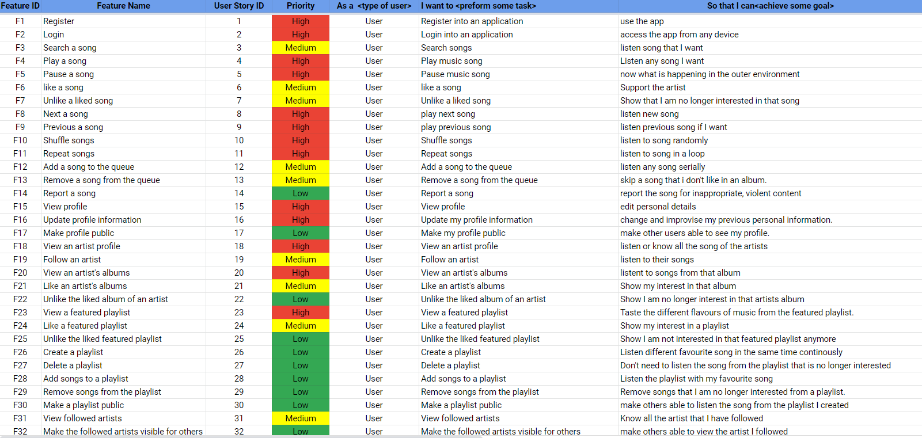

Figure 2: Agile User Stories

A user story is a brief, straightforward description of functionality based on the story of the person who demands the new capability, who is typically a system user or customer. In our case, user stories were discussed along with the team members and the customer. Some of the user stories were also added after the sprints has been started. All the user stories were created according to our application functionality. To add more details to user stories, the stories were split into multiple small user stories and acceptance criteria were made for each user story. Then, user stories were categorized into high, medium, and low prioritization and given story points discussed with each other between the team members. Similarly, user stories were also categorized into epics. There were no user stories that were unnecessary for the application so no user stories were removed until the end of the sprint.

## **Product Backlog**

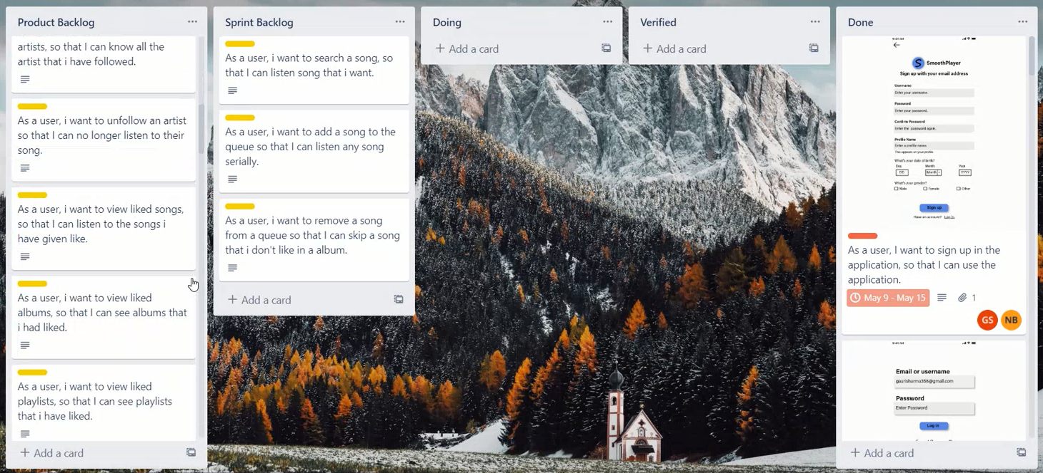

Figure 3: Trello Product Backlog

Product Backlogs are the tasks that are prioritized for the development team which are produced from the roadmap and its need (Alliance, 2022). High prioritized tasks were shown at the top so that the team members know what tasks to perform first. Then the tasks were serially organized according to the prioritization level so that the team members know what to deliver serially according to the prioritization level. Team members only performed the tasks that are on the product backlog. Before any task was performed, the sprint planning meeting was done. Then, the tasks were assigned to the team members. Then the assigned team members for that specific task moved the task from the product backlog to the sprint backlog. They were allowed to only do the only tasks they are assigned.

## **Map Board**

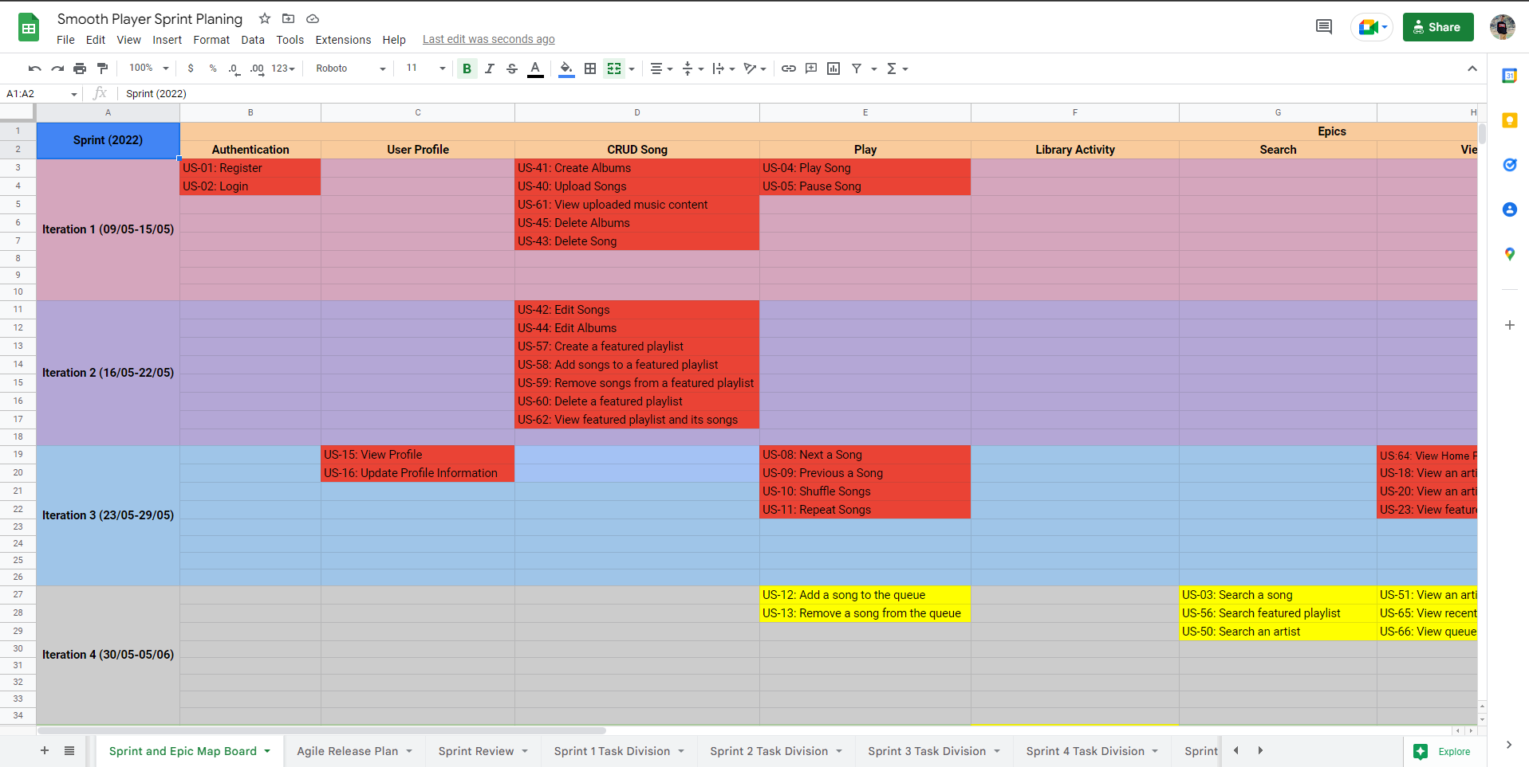

Figure 4: User Story Map Board

The Map board is the table where all the user stories are categorized into epics and divided into multiple sprints. First of all, all user stories were given high, medium, and low priorities, and different epics were defined according to the user stories' functionalities. Then, the user stories are divided into those epics. Similarly, they are also split into different iterations or sprints from high, then medium, and then low priority user stories as first to the last sprint. The user stories which hold even higher priority in high, medium, and low priority were assigned at first in the respective category. Then a map board containing all the epics at the top and sprints on the left side was made and respective user stories along with their id were assigned to the respective epic and sprints. In each sprint, the assigned user stories were completed starting from the top to the bottom.

## **Release Plan**

Figure 5: Agile User Stories Release Plan

The release plan is a product management technique where incremental releases of a product are planned. This process happens after the product backlog, where staged releases are prepared and then divided into several distinct sprints or iterations. The purpose of this plan is to guarantee that the product is consistently progressing in the right direction and that logical releases are occurring often (Mondayblog, 2022). In this plan, all the tasks/user stories were divided into several distinct sprints according to the priority. High-priority features/functionalities were set on the first sprints and respectively. The time duration was estimated for each sprint with the total number of hours needed to complete the tasks in that sprint. The date of commencement and completion was to be set in this meeting. Hence, all the tasks were completed within that estimated time date since the number of hours needed to work on that task was already estimated.

## **Sprint Planning and Backlog**

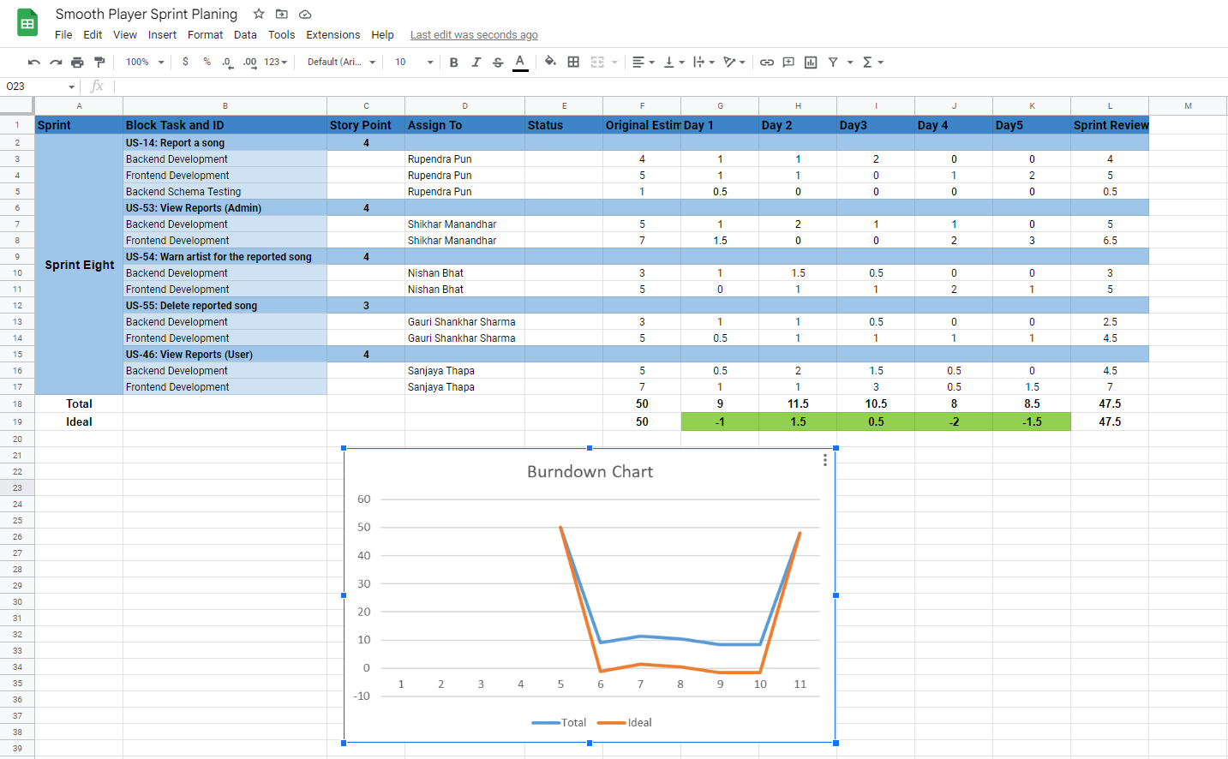

Figure 6: Sprint Planning

Sprint planning is the planning of tasks and time division to the developers before starting the upcoming sprint. In this meeting, high-priority user stories are brought to the sprint backlog from the product backlog. The user stories which have not yet been finished are all listed in the product backlog, while those that will be finished in a sprint are shown in the sprint backlog. In our case, sprint planning meetings were held in the Microsoft team before starting the sprints where the user stories were assigned to each developer after discussion for some minutes. The task division was recorded on the Excel sheet. A user story is also divided furthermore into different parts like frontend and backend, etc. Time estimation was done for each task and some tasks were also completed in the estimated time but some were completed in less time too. Throughout all sprint planning, each developer has done both frontend and backend parts.

## **Daily Stand-Ups**

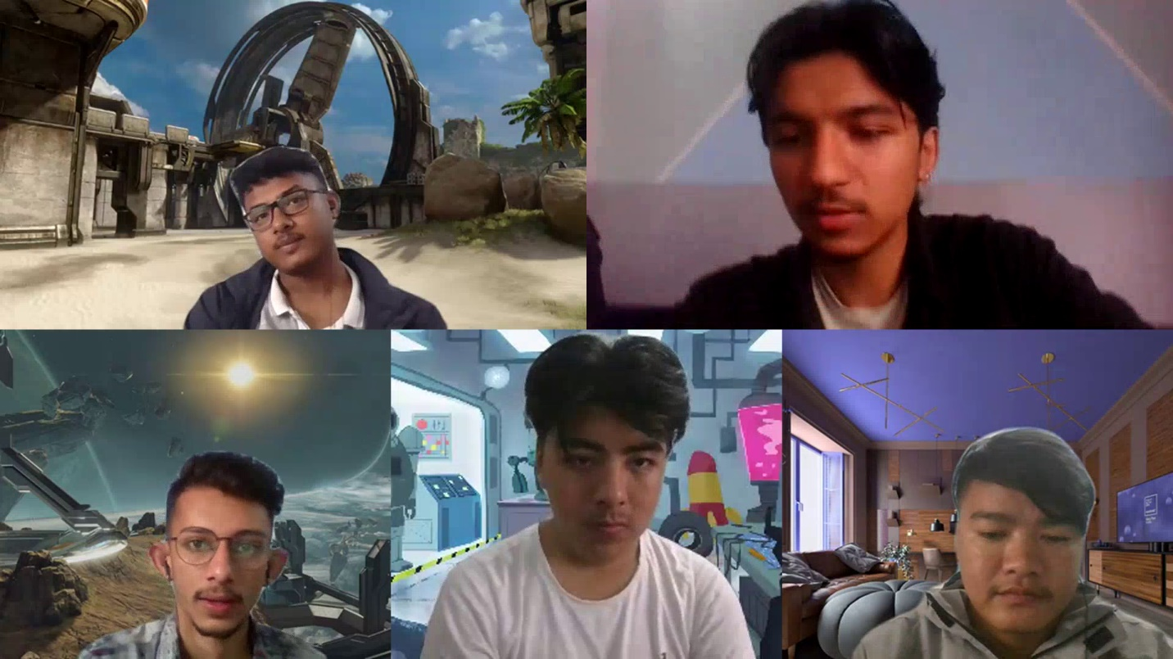

Figure 7: Microsoft Team Daily Stand-Up Meeting

Daily stand-up meetings are crucial to Agile project management. The daily stand-up meeting gives the project team a chance to talk in-depth about the development of a project. Each member can report on their successes since the most recent stand-up meeting at these 15-minute meetings. During Smooth Player development sessions, daily stand-up meetings had been carried out through Microsoft teams. In these sessions, each member reported the accomplishment since the last meeting, what each member was working on before the meeting, and the problems that occurred during the working process. By establishing small, attainable goals that are discussed with the team, this sharing helped to hold team members accountable for their work and commitments. They also enable open communication among team members so that no one is left in the dark about issues, difficulties, or failures. Through collaboration and open communication, team dynamics improved which made working together to complete a project more efficient and pleasurable for everyone (Cloud, 2022).

## **Sprint Review**

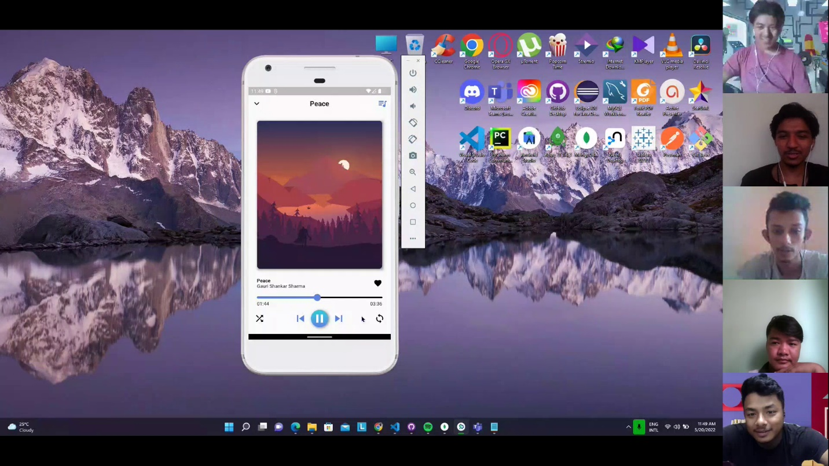

Figure 8: Sprint Review Meeting

The product owner, development team, stakeholders, and Scrum master evaluated the results and determined what can be closed off and what still needs work during the sprint review meeting. As in sprint review, the customer or client reviews the project but, in our case, this is a college project. Hence, our module leader Mr. Pratik sir had been referred to as our client as he review the product. So, the client examined the product, transparently viewed the product’s present state, and offered forum questions, comments, and conversations. In most of the reviews, the feedback was positive as the client was quite satisfied, the comments were almost positive and mostly the conversations were about how to proceed considering the existing circumstances (Singh, 2021).

## **Retro**

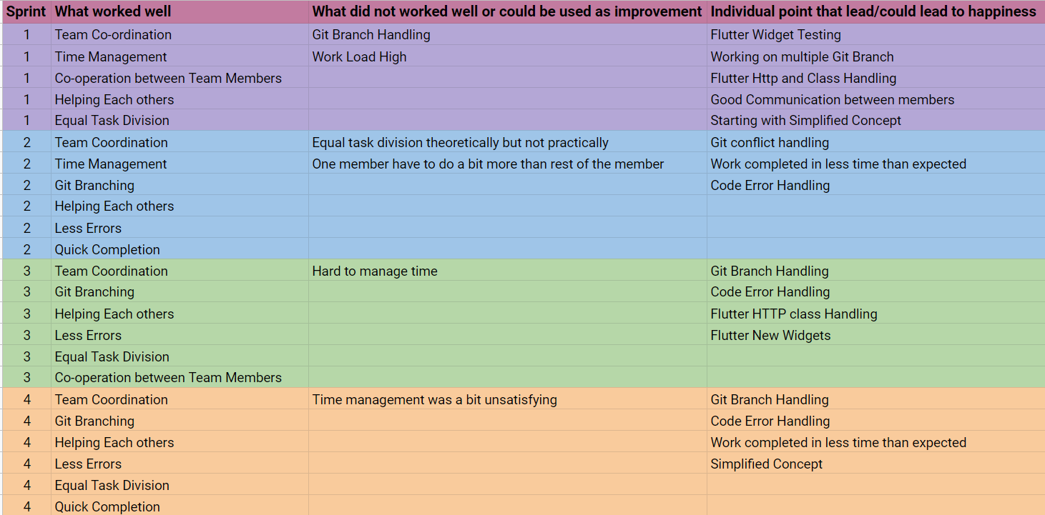

Figure 9: Retrospective Meeting Detail

The sprint retrospective is a routine meeting held after a sprint to evaluate what went well during the previous sprint cycle and what may be improved for the next sprint. The retrospective meeting ensures that essential adjustments are acknowledged and implemented before they are forgotten in the bunch of new tasks. It allows each scrum team member in identifying how they may improve the particular tasks they made contributions to the sprint. Each retrospective meeting usually lasts around one hour.

During each agile sprint retrospective, the development team focuses on increasing product quality by improving the work process. The following are the main questions raised at the meeting.

* What went well in this sprint?
* What went wrong in the spring?
* How should the next sprint play out?
* What did we learn?

## **Why Scrum**

Scrum enables developers to learn through experiences, self-organize while working on a project, and reflect on their wins and losses to improve overall. Software development teams are by far the most likely to use the scrum approach. Its concepts and lessons are suitable for any type of communication. This is one of the reasons behind the popularity of scrum. Scrum is a set of meetings, tools, and responsibilities that help teams plan and reach their goals. An alteration may be encouraged and included in an ongoing project. The project scope is dynamic in a scrum, but the time and cost are fixed. There is no manager in a scrum team to tell them what to do or when they should interact more with the project on their own. Instead of a manager, they have a scrum master who guides members and ensures them from unwanted stress. Furthermore, because of methods like pair programming, their level of acquiring knowledge becomes higher and can be programmed alone which results in faster coding completion time with better quality. Customer satisfaction is also higher when a project is carried out using the scrum methodology. The user may discover that changes to his or her request for work to be done are required. If this occurs, there should be no difficulty because Scrum is built for adaptation and the rapid acceptance of the change (Anon., 2022).

# **Conclusion**

Throughout sprint planning, daily stand-up, sprint review, sprint retrospective, and backlog grooming meetings, the project was completed in time without having any issues at last. Communicating on the Microsoft team has helped the team members to be in sync with everyone and to be up to date. Everyone on the team was very cooperative and conflicts were very rare. During the development of this project, agile has taught us many things like managing time, tasks, and conflicts, working on teams and planning, co-operating with teams, etc. Apart from system design and development, there are others things like communication, consistency, planning, task division, time management, project leading, conflict management, etc. which are very important, and ignoring those things could lead to the failure of the project. In the same way, every team member faced problems at the starting faze but everyone learned how to move forward and during the end period, everyone enhanced their technical, communication, and presentation skills.

# **Links**

**Trello:** <https://trello.com/invite/b/IgISrVzP/ac4a5ff890428697d6848b7e5dcd5a25/smoothplayer>

## **Google Sheet:**

<https://docs.google.com/spreadsheets/d/1Vju4veb-QM07MEcba3md-LFcte7NMLc3p-fFX8XNh9I/edit?usp=sharing>

## **Adobe XD (Google Drive File Link):**

<https://drive.google.com/file/d/1-yMfLCLtqMZhHL8r2kmtVjsOoJQzBtKv/view?usp=sharing>

## **Figma:**

<https://www.figma.com/file/42xznK94zJBTywyWZgDkJN/Smooth-Player?node-id=0%3A1>

# **References**

AgileModeling.com, 2022. *AgileModeling.com.* [Online]   
Available at: http://agilemodeling.com/essays/communication.htm  
[Accessed 22 June 2022].

Alliance, A., 2022. *Agile Alliance.* [Online]   
Available at: https://www.agilealliance.org/glossary/backlog/#q=~(infinite~false~filters~(postType~(~'page~'post~'aa_book~'aa_event_session~'aa_experience_report~'aa_glossary~'aa_research_paper~'aa_video)~tags~(~'backlog))~searchTerm~'~sort~false~sortDirection~'asc~pag  
[Accessed 26 June 2022].

Anon., 2022. *Why Scrum.* [Online]   
Available at: https://www.agilest.org/scrum/why-does-scrum-work/  
[Accessed 03 May 2022].

Anon., 2022. *Workfront.com.* [Online]   
Available at: https://www.workfront.com/project-management/methodologies/scrum/sprint-retrospective#:~:text=The%20sprint%20retrospective%20is%20a%20recurring%20meeting%20held%20at%20the,delivering%2C%20and%20managing%20complex%20projects.

Bhasin, H., 2021. *Marketing91.* [Online]   
Available at: https://www.marketing91.com/face-to-face-communication/  
[Accessed 23 June 2022].

Business, R. f., 2022. *Reference for Business.* [Online]   
Available at: https://www.referenceforbusiness.com/management/Str-Ti/Teams-and-Teamwork.html#:~:text=A%20team%20is%20a%20collection,teams%20and%20with%20the%20organization.  
[Accessed 21 06 2022].

Cloud, A. E., 2022. *Adobe Experience Cloud.* [Online]   
Available at: https://www.workfront.com/project-management/methodologies/agile/daily-stand-up  
[Accessed 29 June 2022].

Essays, S. Y., 2022. *Share Your Essays.* [Online]   
Available at: https://www.shareyouressays.com/knowledge/3-major-theories-of-communication-as-propounded-by-different-schools-of-management/99237  
[Accessed 24 June 2022].

Lino, C., 2016. *PositivePsychology.com.* [Online]   
Available at: https://positivepsychology.com/psychology-teamwork/#:~:text=One%20of%20the%20definitions%20of,own%20and%20their%20organization's%20goals.  
[Accessed 22 June 2022].

Mondayblog, 2022. *Mondayblog.* [Online]   
Available at: https://monday.com/blog/rnd/agile-release-planning/#:~:text=Agile%20release%20planning%20is%20a,several%20different%20sprints%20or%20iterations  
[Accessed 27 June 2022].

Mortensen, M. H. a. M., 2022. *Harvard Business Review.* [Online]   
Available at: https://hbr.org/2016/06/the-secrets-of-great-teamwork  
[Accessed 21 June 2022].

Singh, V., 2021. *Tools.* [Online]   
Available at: https://www.toolsqa.com/agile/scrum/sprint-review/  
[Accessed 01 May 2022].

Software, M. G., 2022. *Mountain Goat Software.* [Online]   
Available at: https://www.mountaingoatsoftware.com/agile/user-stories  
[Accessed 25 June 2022].

Teamrg, 2022. *Teamrg.com.* [Online]   
Available at: https://www.teamrg.com/blog/communication-in-the-agile-project-lifecycle  
[Accessed 22 June 2022].

UK, Y. E., 2022. *Youth Employment UK.* [Online]   
Available at: https://www.youthemployment.org.uk/young-professional-training/teamwork-skills-young-professional/  
[Accessed 21 June 2022].

Waters, S., 2022. *BetterUp.* [Online]   
Available at: https://www.betterup.com/blog/what-is-teamwork#:~:text=With%20effective%20teamwork%20comes%20more,to%20challenge%20each%20other's%20assumptions.  
[Accessed 21 June 2022].